WORKSHEET 4

NAME : SANJIVKUMAR A
ROLL NO : 26MX217

Push.html
<!DOCTYPE html>
<html>
<head>
<title>Push Example</title>
<style>
body {
font-family: Arial;
text-align: center;
margin: 40px;
}

input, textarea {
padding: 10px;
margin: 10px;
width: 300px;
}

button {
padding: 10px 20px;
}

footer {
margin-top: 50px;
padding: 15px;
border-top: 1px solid gray;
}
</style>
</head>

<body>

<h2>Add Element Using push()</h2>

<input type="text" id="input" placeholder="10,20,30">
<br>

<button onclick="execute()">Execute</button>
<br>

<textarea id="output" readonly></textarea>

<script>
function execute() {
let arr = document.getElementById("input").value.split(",").map(Number);

arr.push(100);

document.getElementById("output").value = arr.join("\n");
}
</script>

<footer>
© 26MX217 | Sanjivkumar
</footer>

</body>
</html>

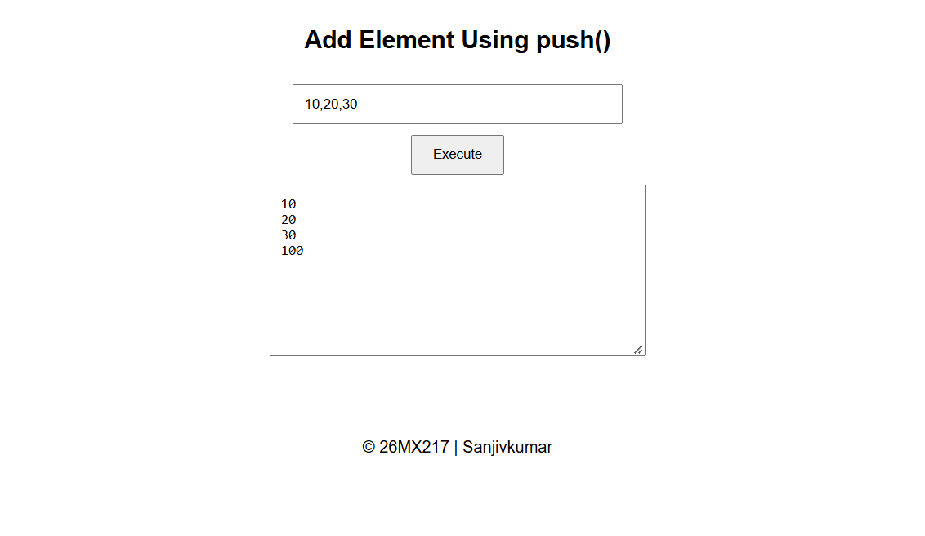
Pop.html

<!DOCTYPE html>
<html>
<head>
<title>Pop Example</title>
<style>
body {
font-family: Arial;
text-align: center;
margin: 40px;
}

input, textarea {
padding: 10px;
margin: 10px;
width: 300px;
}

button {
padding: 10px 20px;
}

footer {
margin-top: 50px;
padding: 15px;
border-top: 1px solid gray;
}
</style>
</head>

<body>

<h2>Remove Last Element Using pop()</h2>

<input type="text" id="input" placeholder="10,20,30,40">
<br>

<button onclick="execute()">Execute</button>
<br>

<textarea id="output" readonly></textarea>

<script>
function execute() {
let arr = document.getElementById("input").value.split(",").map(Number);

arr.pop();

document.getElementById("output").value = arr.join("\n");
}
</script>

<footer>
© 26MX217 | SanjivKumar
</footer>

</body>
</html>

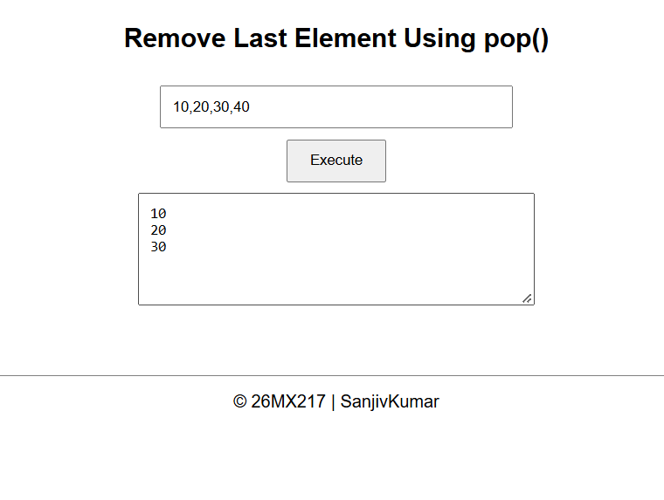
Concat.html

<!DOCTYPE html>
<html>
<head>
<title>Concat Example</title>
<style>
body {
font-family: Arial;
text-align: center;
margin: 40px;
}

input, textarea {
padding: 10px;
margin: 10px;
width: 300px;
}

button {
padding: 10px 20px;
}

footer {
margin-top: 50px;
padding: 15px;
border-top: 1px solid gray;
}
</style>
</head>

<body>

<h2>Combine Two Arrays Using concat()</h2>

<input type="text" id="input" placeholder="10,20,30,40">
<br>

<button onclick="execute()">Execute</button>
<br>

<textarea id="output" readonly></textarea>

<script>
function execute() {

let arr = document.getElementById("input").value.split(",").map(Number);

let middle = arr.length / 2;

let first = arr.slice(0, middle);
let second = arr.slice(middle);

let result = first.concat(second);

document.getElementById("output").value = result.join("\n");
}
</script>

<footer>
© 26MX217 | SanjivKumar
</footer>

</body>
</html>
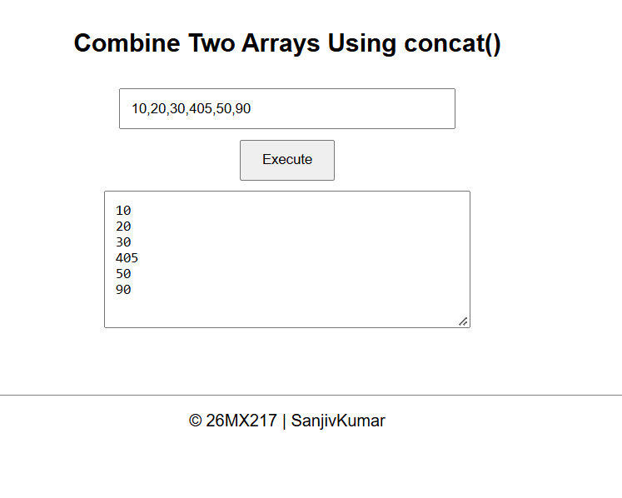

For_each.html

<script>
function execute() {

let arr = document.getElementById("input").value.split(",");

let result = "";

arr.forEach(function(name) {
result += name + "\n";
});

document.getElementById("output").value = result;
}
</script>
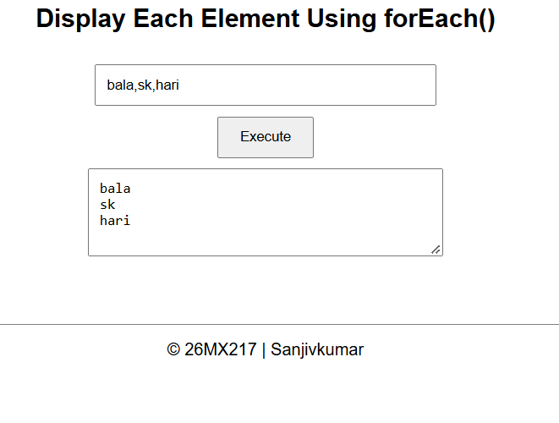

For_of.html
<script>
function execute() {

let arr = document.getElementById("input").value.split(",").map(Number);

let result = "";

for (let num of arr) {
result += num + " -> " + (num * num) + "\n";
}

document.getElementById("output").value = result;
}
</script>
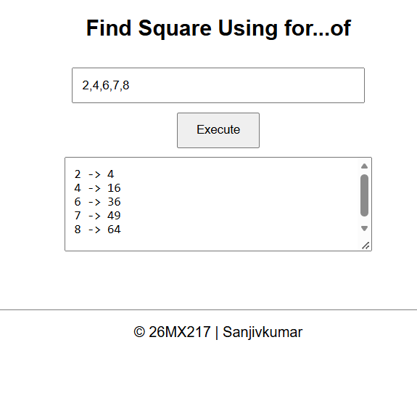
For_in.html
<script>
function execute() {

let arr = document.getElementById("input").value.split(",");

let result = "";

for (let index in arr) {
result += index + " : " + arr[index] + "\n";
}

document.getElementById("output").value = result;
}
</script>
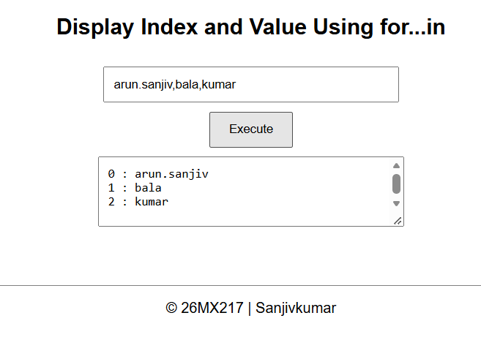
add_10_ele.html

<script>
function execute() {

let arr = document.getElementById("input").value.split(",").map(Number);

let result = [];

arr.forEach(function(num) {
result.push(num + 10);
});

document.getElementById("output").value = result.join("\n");
}
</script>
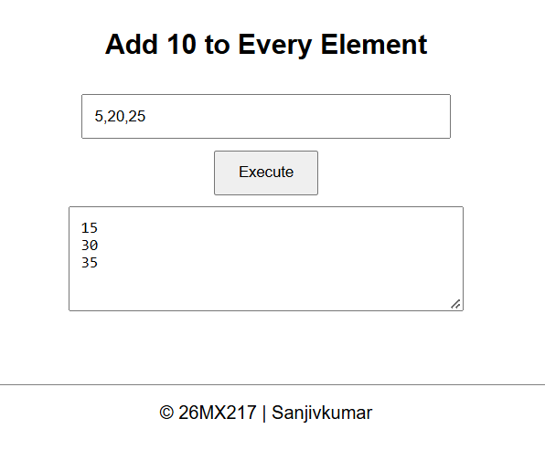

for_each_even_nos.html
<script>
function execute() {

let arr = document.getElementById("input").value.split(",").map(Number);

let sum = 0;
let even = "";

for (let num of arr) {

if (num % 2 == 0) {
even += num + " ";
sum += num;
}
}

document.getElementById("output").value =
"Even numbers: " + even + "\nSum: " + sum;
}
</script>
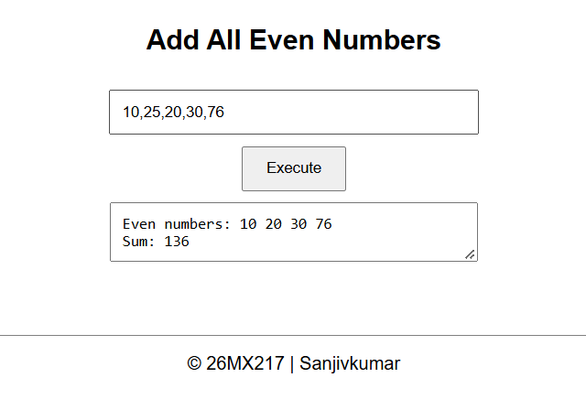

stack.html

<!DOCTYPE html>
<html>
<head>
<title>Stack</title>
<style>
body {
font-family: Arial;
text-align: center;
margin: 40px;
}

input, textarea {
padding: 10px;
margin: 10px;
width: 300px;
}

button {
padding: 10px 20px;
margin: 5px;
}

footer {
margin-top: 50px;
padding: 15px;
border-top: 1px solid gray;
}
</style>
</head>

<body>

<h2>Stack Using push() and pop()</h2>

<input type="text" id="input" placeholder="Enter element">
<br>

<button onclick="pushElement()">Push</button>
<button onclick="popElement()">Pop</button>
<button onclick="displayStack()">Display Stack</button>

<br>

<textarea id="output" rows="8" readonly></textarea>

<script>

let stack = [];

function pushElement() {

let value = document.getElementById("input").value;

if (value == "") {
alert("Enter a value");
return;
}

stack.push(value);

document.getElementById("input").value = "";

displayStack();
}

function popElement() {

if (stack.length == 0) {

document.getElementById("output").value = "Stack Empty";

} else {

stack.pop();

displayStack();
}
}

function displayStack() {

if (stack.length == 0) {

document.getElementById("output").value = "Stack Empty";

} else {

document.getElementById("output").value = stack.join("\n");
}
}

</script>

<footer>
© 26MX217 | Sanjivkumar
</footer>

</body>
</html>
